Software Design and Development
UA92. 133.B3.25/26
Assignment 1
Team Report

Group Name: CinemaHub

Contents
Contents
Analysis 4
Introduction 4
Project Features 4
SWOT 4
Requirement Engineering 4
Risk Analysis 4
User Acceptance Criteria 4
Project Management 4
Team Working Strategy 4
Methodologies 4
Design 4
Design Models 4
Design Prototype 4
Security Architecture 4
Development 4
Tools/Languages 4
Architecture decisions 4
Database creation 4
Key features implemented 4
Version control 4
Challenges faced 4
Testing 4
Test Plan 4
Error Fixes 4
Professional Considerations 4
Legal Considerations 4
Social Considerations 4
Ethical Considerations 4
Professional Considerations 4

Analysis

Introduction

Project Features

SWOT

Requirement Engineering

Elicitation Technique: Interview

Justification:
Interviews were selected as the primary requirements elicitation technique because they allow detailed and targeted exploration of user needs. For a cinema booking system, interviews are particularly suitable as they enable follow-up questions about booking behaviour, seat selection, payment expectations, and operational workflows. This ensures that both functional and non-functional requirements are based on realistic user experiences rather than assumptions.

Stakeholders / Clients
- Cinema Customers
- Cinema Staff
- Cinema Manager
Justification:
Cinema customers are the primary users of the system and interact directly with the booking interface. Cinema staff rely on the system to support customers, manage seat availability, and resolve booking issues. Cinema managers are key stakeholders as they require access to reports, pricing controls, and system reliability to manage cinema operations and business performance effectively.

Interview Questions

Cinema Customers
- How do you usually buy cinema tickets?
- When booking online, do you want to choose your seat yourself or have the system assign one?
- What information do you need to see before booking a ticket?
- Would you prefer to book tickets without creating an account?
- What device do you usually use when booking tickets online?
- What payment methods do you expect to use?
- How would you like to receive your ticket after booking?
- Do you expect to be able to cancel or change a booking?
- Have you experienced issues with cinema booking systems before?
- What would stop you from using a cinema booking system again?
Justification:
These questions focus on identifying how customers search for films, select seats, complete payments, and receive tickets. The questions are designed to capture usability expectations and common problems to ensure the booking process is efficient, clear, and accessible.

Cinema Staff
- What is your role at the cinema?
- How do you currently check seat availability?
- Do you need seat availability to update in real time?
- How are refunds or cancellations currently handled?
- What booking information do you need when helping customers?
- Do seats ever need to be manually blocked?
- How do you handle customers with online booking issues?
- What problems occur during busy periods?
- What information helps you work more efficiently?
Justification:
Staff questions focus on operational workflows, customer support needs, and system reliability. This helps identify system functions that reduce delays, prevent errors, and support staff during peak times.

Cinema Manager
- What are your main responsibilities at the cinema?
- What information do you need to manage daily operations?
- Do you need access to ticket sales reports?
- How important is knowing which films and showtimes are most popular?
- Do you need to change ticket prices?
- Should the system support discounts or promotions?
- How are peak times currently managed?
- How important is system reliability during busy periods?
Justification:
Manager questions focus on business-level requirements such as reporting, pricing control, and performance monitoring. These ensure the system supports decision-making and long-term operational efficiency.

Simulated Interview Responses

To reflect realistic interview data, a combination of direct quotes and summarised responses was used. For example, some customers stated that they “prefer to choose seats themselves to avoid being separated,” while others prioritised speed and simplicity over additional options. Staff responses highlighted the importance of real-time seat updates, with one staff member noting that “seat availability must update instantly during busy periods.” Managers emphasised reliability and reporting, stating that “system stability during peak times is critical to cinema operations.” Overall, the responses were analysed to identify common themes and expectations across different user groups.

Key Findings from Responses
- Customers expect online booking with manual seat selection and clear pricing information.
- Staff require real-time seat availability and quick access to booking details.
- Managers need reliable reporting, pricing flexibility, and system stability during peak periods.

Summary
This requirement gathering focuses specifically on interview-based elicitation. It expands and clarifies stakeholder justification, ensures all interview questions are fully documented, and improves the explanation of simulated responses. The changes strengthen the depth and clarity of the requirements gathering process while remaining within the defined scope of this role.

System Requirements
ID | Type | Description
UR1 | User | The user should be able to browse a list of cinemas and halls.
UR2 | User | The user should be able to filter showtimes by date, movie, or cinema.
UR3 | User | The user should be able to view the seating layout with available and occupied seats.
UR4 | User | The user should be able to select seats and place an order.
UR5 | User | The user should be able to pay for tickets using a card or electronic wallet.
UR6 | User | The user should receive a booking confirmation via email.
UR7 | User | The user should be able to cancel a booking before the session starts.
UR8 | User | The admin should be able to manage movies, sessions, and pricing.
FR1 | Functional | The system displays the schedule from the database with filters applied.
FR2 | Functional | The system shows a real-time seating layout (occupied seats from the database).
FR3 | Functional | The system temporarily reserves selected seats for 10 minutes during checkout.
FR4 | Functional | The system calculates the total price based on seat types and quantity.
FR5 | Functional | The system sends an email with a ticket QR code after successful payment.
FR6 | Functional | The system allows cancellations with refunds.
FR7 | Functional | Admin panel for CRUD operations on movies and sessions.
NFR1 | Non-Functional | Response time ≤ 3 seconds for key actions (load schedule, select seats).
NFR2 | Non-Functional | System uptime ≥ 99.5% per month.
NFR3 | Non-Functional | HTTPS encryption for all transactions and data.
NFR4 | Non-Functional | Scalability: support for 1000+ concurrent users.
NFR5 | Non-Functional | Responsive UI for desktop and mobile (Bootstrap or similar).
NFR6 | Non-Functional | Logging of all user and system actions for audit purposes.

Justification (Requirements Section)
To identify user goals (requirements), system operations (behavior), and the quality characteristics (constraints) we categorized them into three types (UR, FR, NFR) to assist the team in designing and testing every aspect of the project.
A number was assigned to each of our requirements using a numerical table (UR1, FR1, NFR1) which allows for quicker communication and discussion between the team members when relating the requirements to each other, and to relate the requirements to designs and testing.
The User Requirements were developed from real world uses in a cinema environment (i.e. showing movies, picking your seats, managing movies) to keep the focus on user and business needs.
Functional Requirements translate those user needs into the actions that the system will perform (i.e. displaying a schedule of movies, reserving seats, processing payment, sending confirmation email, etc.), thereby making the implementation of each requirement clear to everyone.
Non-Functional Requirements establish the targets for performance, availability, security and usability for the movie ticket booking system, to ensure that everyone knows what will be considered "good enough".

Risk Analysis
RN | Risk | Likelihood | Impact | Justification | Mitigation / Strategy
R1 | Payment processing failure | Medium | High | Online payments rely on third-party services and network stability, which can fail or timeout. | Use a reliable payment gateway, validate transactions server-side, and implement retry/error handling with clear user feedback.
R2 | Double booking of seats | Medium | High | Multiple users may attempt to book the same seat simultaneously. | Implement seat locking during checkout and database transactions to ensure atomic updates.
R3 | Data security breach | Low–Medium | High | The system stores personal and booking data, making it a target for attacks. | Use HTTPS, hash passwords, apply role-based access, and follow security practices.
R4 | System downtime | Low–Medium | Medium | Server or hosting outages can make the system unavailable. | Use reliable hosting, monitoring tools, and regular backups; plan maintenance windows.
R5 | Poor user experience | Medium | Medium | A confusing interface may cause users to abandon bookings. | Use wireframes, prototypes, user testing, and iterative UI improvements based on feedback.
R6 | Inaccurate showtime or movie data | Low | Medium | Manual data entry can introduce errors. | Validate inputs, restrict admin editing rights, and add confirmation checks.
R7 | Team member unavailability | Medium | Medium | Illness or scheduling conflicts can slow progress. | Share knowledge, document code, and distribute tasks so no area depends on one person.
R8 | Scope creep | Medium | Medium | Adding extra features late can delay delivery. | Clearly define requirements early and prioritise essential features.
R9 | Incomplete Error Handling | Medium | Medium | If errors aren’t handled properly, users may be confused or lose bookings. | Clear error messages, logging, and fallback behaviour for failed actions.
R10 | Failure to Comply with GDPR | Low-Medium | High | The system process and stores personal data, so poor data handling could breach GDPR Regulations | Minimise stored data, provide clear privacy policies and restrict access to sensitive info.
R11 | Weak Authentication | Medium | Medium | Poor Login security could allow unauthorised access to accounts or admin features. | Enforce strong password security and implement lockouts after failed attempts.
R12 | Uneven Work Load Distribution | Low | Medium | Some features may require more effort, causing delays if one person becomes overloaded. | Regular check-ins, task tracking and clear instructions provided to each team member.
R13 | Misunderstanding Requirements | Low | High | Misinterpreting requirements can lead to building the wrong features. | Clarification, written requirements, and regular contact and check-ins.

Risk Analysis Justification
Risk analysis was carried out to identify potential technical, security, and project-related issues that could negatively impact the development and operation of the cinema booking system. Identifying these risks early allows appropriate mitigation strategies to be planned in order to reduce their likelihood or minimise their impact. For example, risks such as payment processing failure and double booking of seats were identified due to the system’s reliance on online transactions and real-time seat availability. Data security breaches were also considered, as the system stores personal and booking information that must be protected to maintain user trust. In addition, project risks such as system downtime and scope creep were included to reflect potential issues that could affect delivery times and system reliability. Overall, the risk analysis helps ensure the system is reliable, secure, and suitable for both users and cinema staff.

User Acceptance Criteria
Stories
- As a new customer I want to create an account so that I can book tickets faster and view my booking history.
- As a registered customer I want to log in securely so that I can access my profile and saved bookings.
- As a guest user I want to book tickets without creating an account so that I can make a quick purchase.
- As a customer I want to see a list of movies currently showing so that I can choose what to watch.
- As a customer I want to view movie details (synopsis, duration, rating, trailer)
so that I can decide if the movie interests me.
- As a customer I want to filter movies by genre, language, and rating so that I can find movies that match my preferences.
- As a customer I want to see available showtimes for a selected movie so that I can choose a convenient time.
- As a customer I want to choose a cinema location so that I can see shows near me
- As a customer I want to see the seating layout for a selected show so that I can choose my preferred seats.
- As a customer I want to select one or more available seats So that I can sit where I want during the movie.
- As a customer I want unavailable seats to be clearly marked so that I don’t accidentally select seats already booked.
- As a customer I want to see the total ticket price before payment so that I know exactly what I’m paying.
- As a customer I want to pay using a secure payment method so that my booking can be confirmed.
- As a customer I want to be notified if my payment fails so that I can retry or choose another payment method.
- As a customer I want to receive a booking confirmation so that I know my tickets are successfully booked.
- As a customer I want to receive an e-ticket so that I can enter the cinema easily.
- As a logged-in customer I want to view my past and upcoming bookings so that I can manage my movie plans.
- As a customer I want to cancel my booking before the showtime so that I can get a refund if my plans change.
- As a customer I want to receive a refund after cancellation so that I don’t lose money.

Acceptance Criteria
- Given I am not registered
When I provide registration details
Then my account is successfully created
Given I enter incorrect or incomplete information
Then I am given a clear error message telling me this
Then I receive conformation telling me that registration was a success
- Given I have a registered account
When I enter valid credentials
Then I am logged in successfully
Given I enter incorrect details
Then I see an authentication error
Then my session remains secure until I log out
- Given I am not logged in
When I select a movie and proceed to booking
Then I can complete it as a guest
Then I am required to provide an email to recieve tickets
Then I am not required to create an account
- Given I open the application
Then I see all the currently showing movies
Then each movie displays its title and poster
Then unavailable or expired showings are not visible
- Given I select a movie
Then I see the movies information (Length, Genre, etc)
Then the information shown matches the movie selected.
- Given movies are displayed
When I apply filters
Then only suitable movies are shown
Then I can clear filters to see the whole list
- Given I select a movie
Then I see a list of available show times
Then showtimes are grouped by date and cinema
Then unavailable showtimes are not selectable

Project Management

Team Working Strategy

Methodologies

Design

Design Models

Level 0
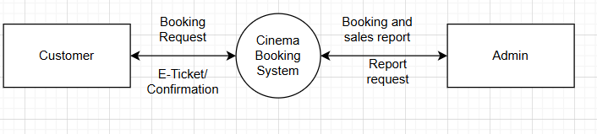
Level 1
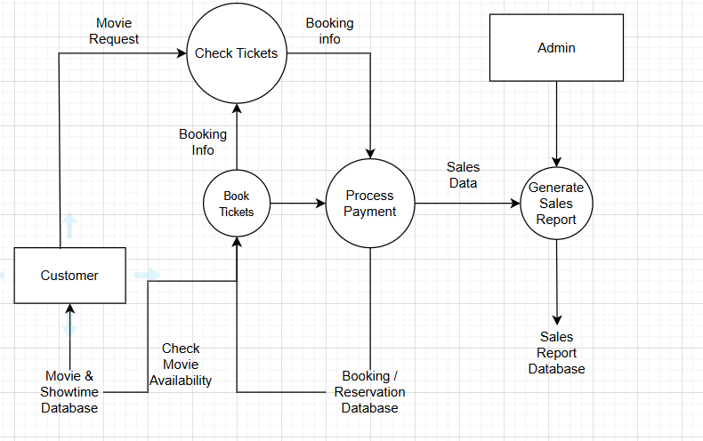
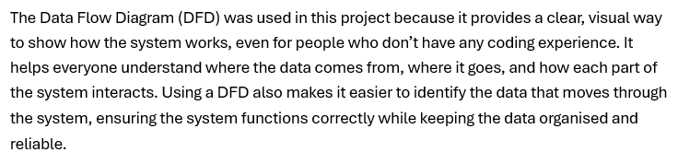

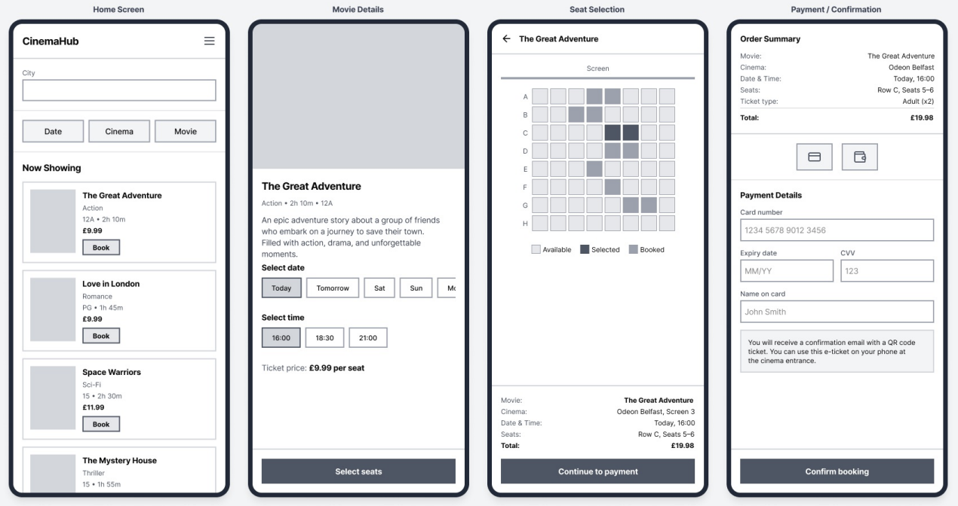
Design Prototype

Security Architecture

Development

Tools/Languages

Architecture decisions

Database creation

Key features implemented

Version control

Challenges faced

Testing

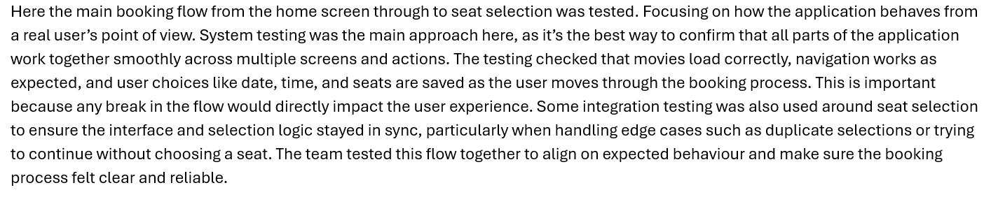
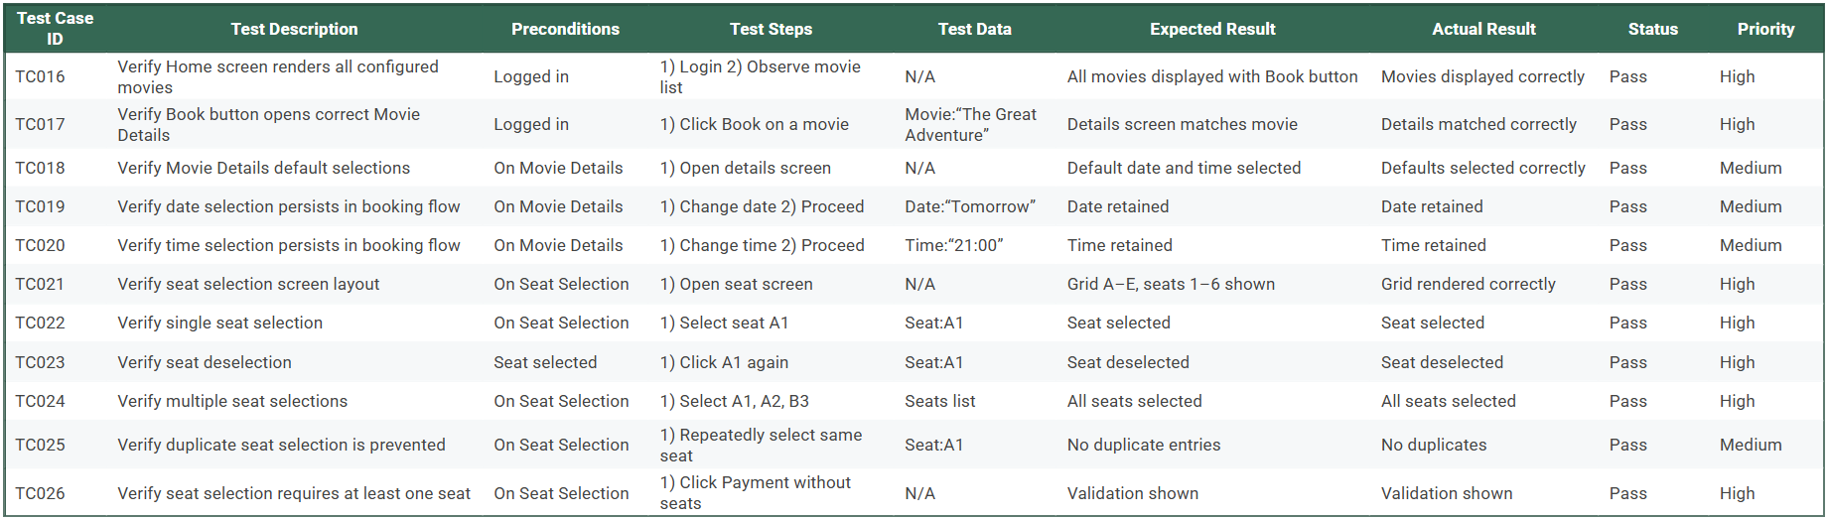
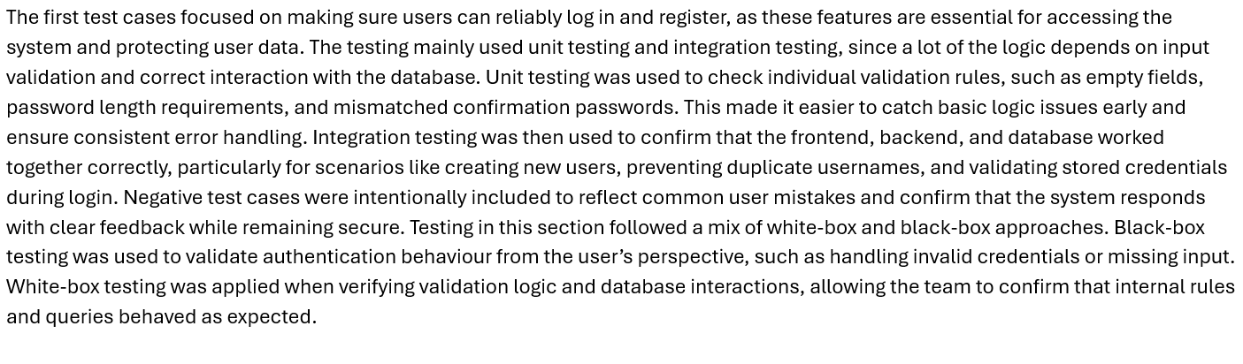
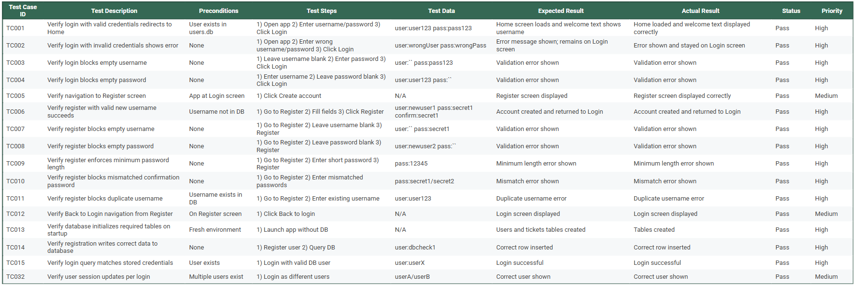
Test Plan
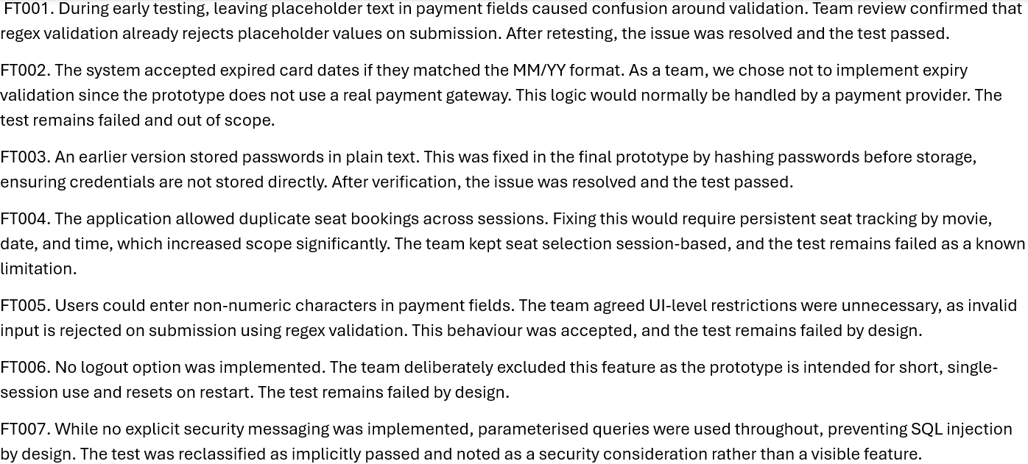
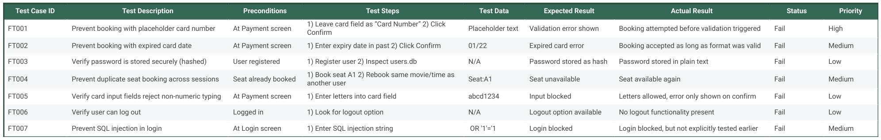
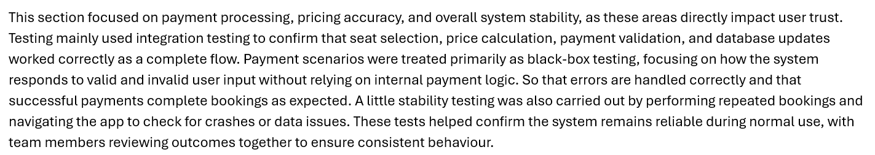
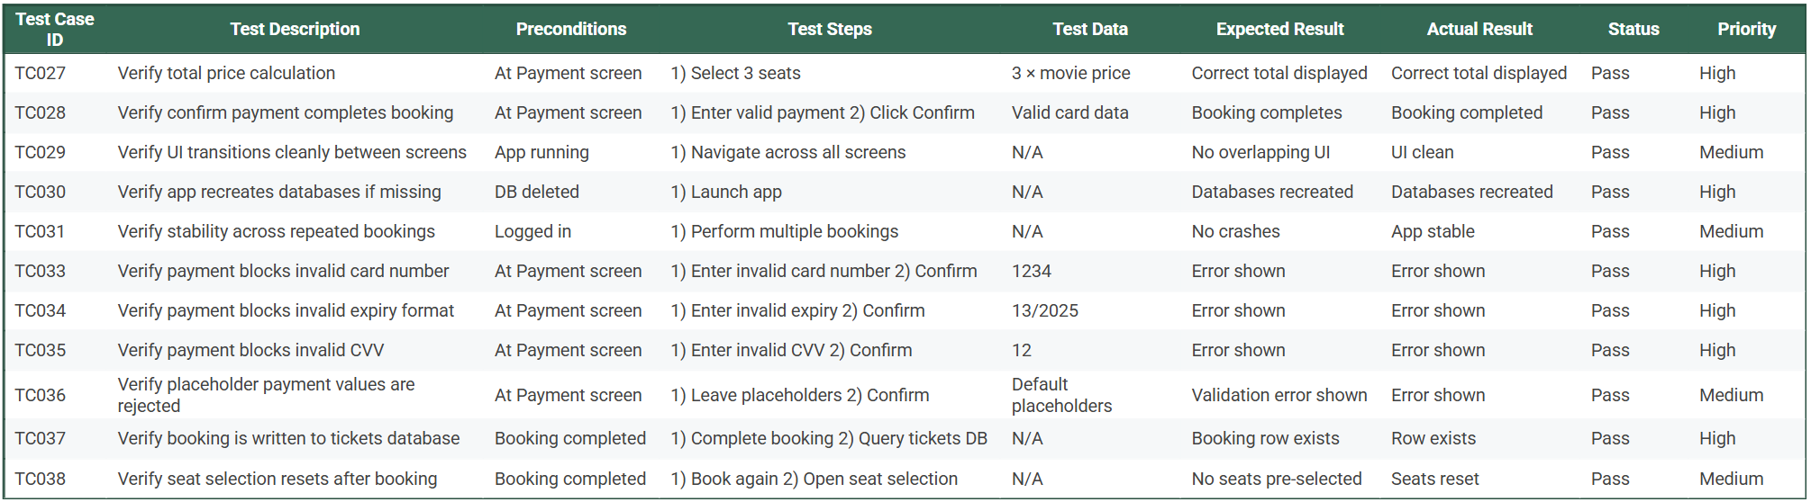

Error Fixes

Professional Considerations

Legal Considerations

Social Considerations

Ethical Considerations

Professional Considerations

